Technical Architecture:

Project Design Phase-II Technology Stack (Architecture & Stack)

|  |  |
| --- | --- |
| Date | 19 October 2022 |
| Team ID | PNT2022TMID23730 |
| Project Name | Project - Real-Time Communication System Powered by AI for Specially Abled |
| Maximum Marks | 4 Marks |

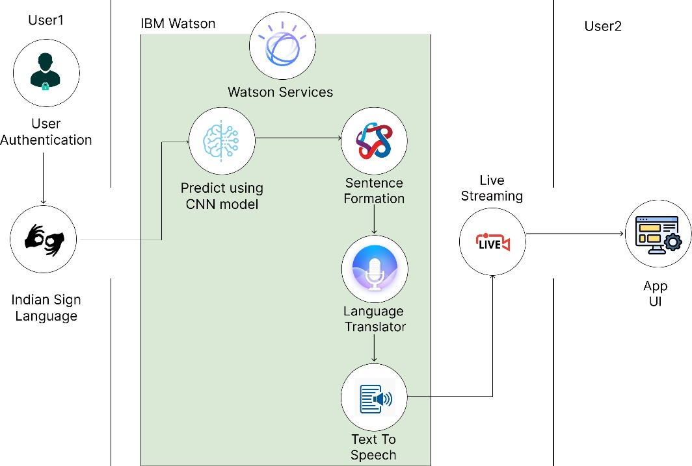

Table-1 : Components & Technologies:

|  |  |  |  |
| --- | --- | --- | --- |
| **S.No** | **Component** | **Description** | **Technology** |
| 1. | User Interface | WEB UI | HTML, CSS, Python (Flask). |
| 2. | Application Logic-1 | Logic for a process in the application | Python |
| 3. | Application Logic-2 | Logic for a process in the application | IBM Watson STT service |
| 4. | Application Logic-3 | Logic for a process in the application | IBM Watson Assistant |
| 5. | Database | Data Type, Configurations etc. | NoSQL |
| 6. | Cloud Database | Database Service on Cloud | IBM DB2, IBM Cloudant, etc |
| 7. | File Storage | File storage requirements | IBM Block Storage or Other Storage Service or Local Filesystem |
| 8. | Machine Learning | To predict the Indian Sign Language for the specially abled | Convolutional Neural Network |
| 9. | Infrastructure (Server / Cloud) | Application Deployment on Local System / Cloud Local Server Configuration:  Cloud Server Configuration: | Local, Cloud Foundry, Kubernetes, etc. |

Table-2: Application Characteristics:

|  |  |  |  |
| --- | --- | --- | --- |
| **S. No** | **Characteristics** | **Description** | **Technology** |
| 1. | Open-Source Frameworks | The open-source frameworks used | TensorFlow, Flask, OpenCV |
| 2. | Security Implementations | The security / access controls implemented, use of firewalls etc. | e.g. SHA-256, Encryptions, IAM Controls, OWASP etc. |
| 3. | Scalable Architecture | Justify the scalability of architecture (3 – tier, Micro-services) | Each tier can be developed separately without impacting other tiers,  HTML, CSS and JavaScript for UI,  Python for application tier and IBM DB2 for cloud storage and processing |

|  |  |  |  |
| --- | --- | --- | --- |
| **S. No** | **Characteristics** | **Description** | **Technology** |
| 4. | Availability | Justify the availability of application (e.g. use of load balancers, distributed servers etc.) | The application is distributed, with the help of pay as you go model available in  cloud |
| 5. | Performance | Design consideration for the performance of the  application (number of requests per sec, use of Cache, use of CDN’s) etc. | Cache memory is useful for accessing  user’s previous sign requests, authentication approval etc. |

References:

<https://c4model.com/>

<https://developer.ibm.com/patterns/online-order-processing-system-during-pandemic/> <https://www.ibm.com/cloud/architecture>

<https://aws.amazon.com/architecture>

<https://medium.com/the-internal-startup/how-to-draw-useful-technical-architecture-diagrams-2d20c9fda90d>